# 1 INTRODUCTION

1.1 Overview

# Retail Management refers to the process of helping customers find products in your store. It includes everything from increasing your customer pool to new products are presented, and how you fulfill a customer’s needs.

1.2 Purpose

# RMS can help retailers streamline all the processes of running a store, from procurement to sales and back-office activities such as accounting and human resources.

**2 Problem Definition & Design Thinking**

2.1 Empathy Map

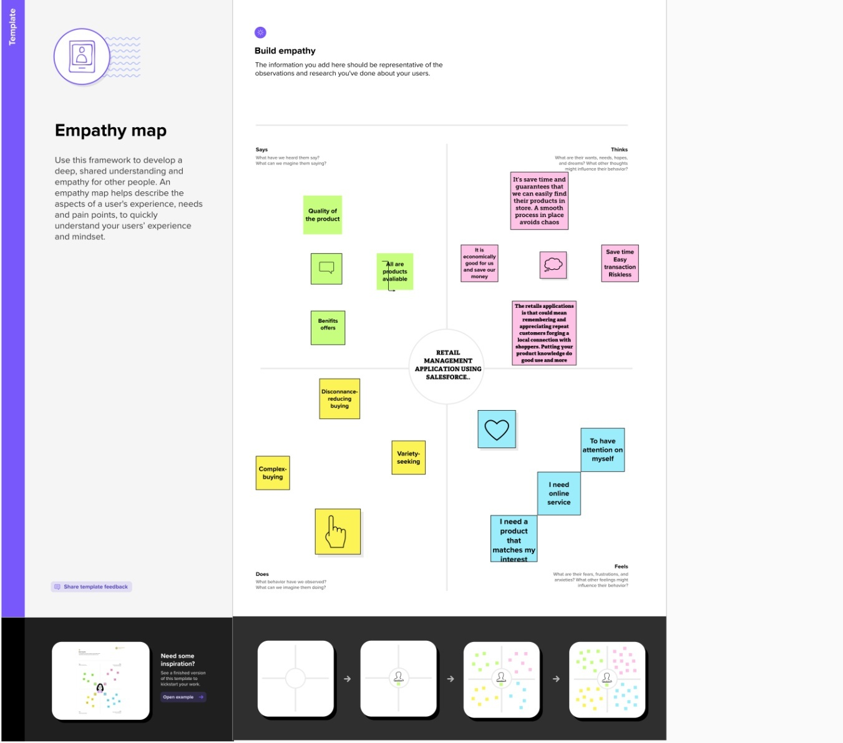

2.2 Ideation & Brainstorming Map

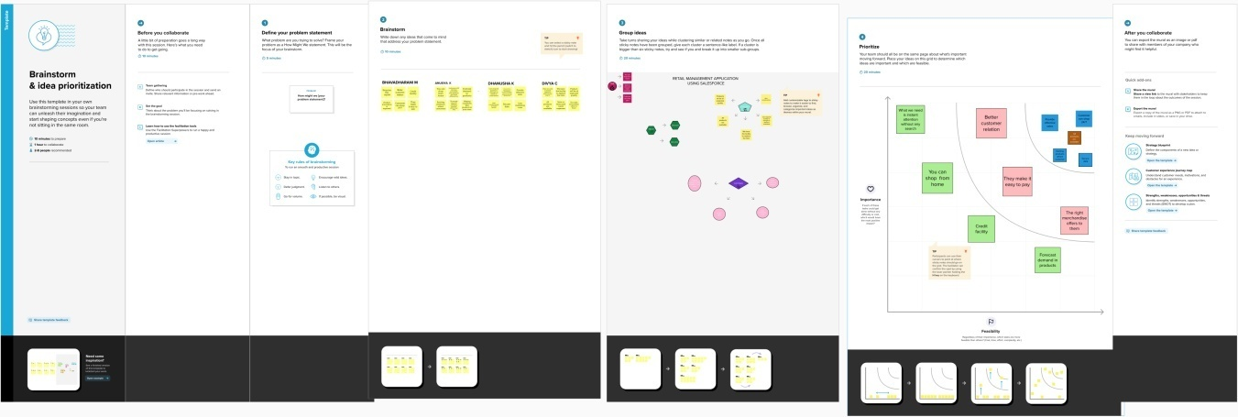

# 3 RESULT

3.1 Data Model:

Dispatched Check box

Expected date of delivery Check box

|  |  |  |
| --- | --- | --- |
| Object Name | Fields in the Object | |
| Dispatch\Tracking | Field label | Data Type |
|  |  |
|  |  |
| Tracking ID | Check box |
| Sales order | Chech box |

# 3.2 Activity & Screenshot

# 1. Creating Developer Account

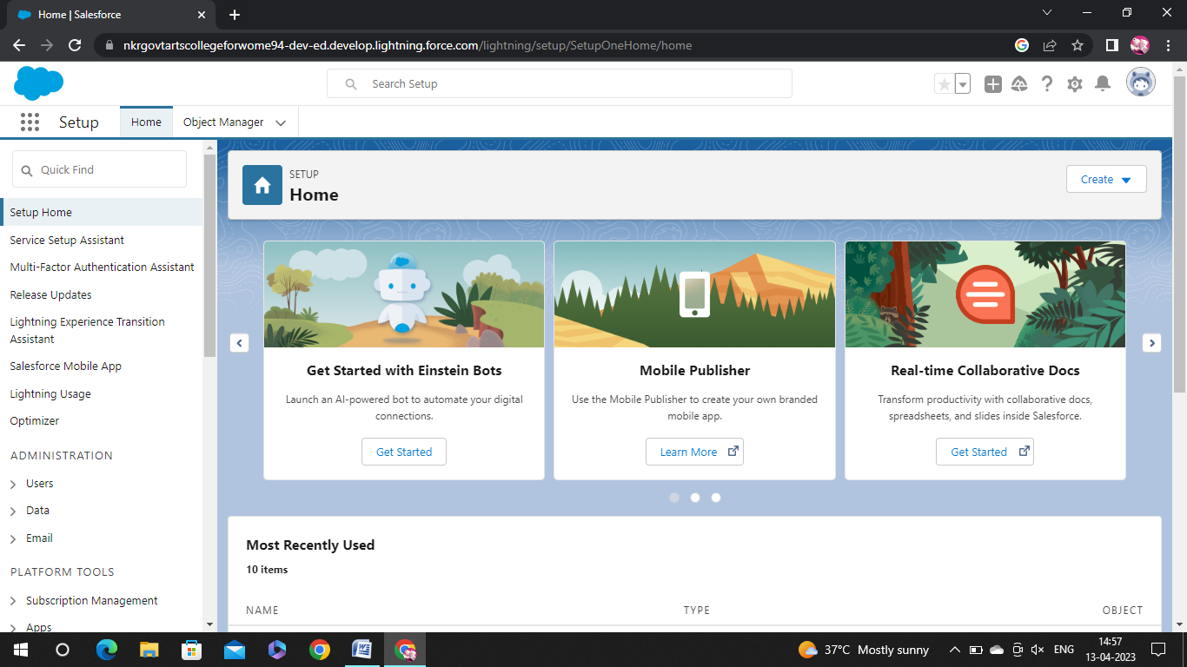

2. Objects: 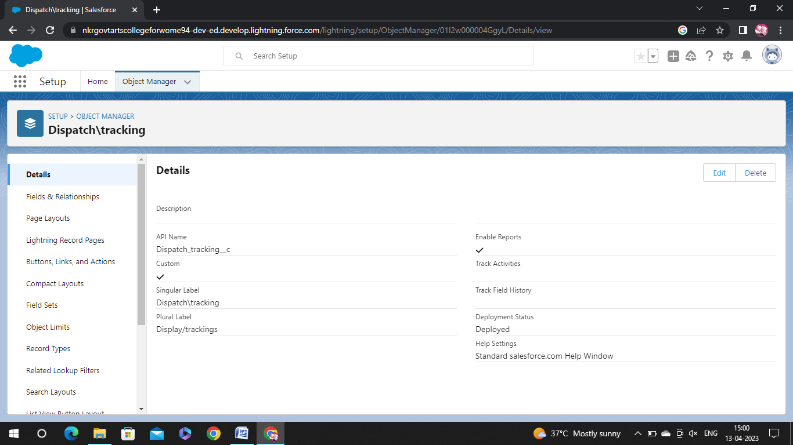

3. Relationship between objects:

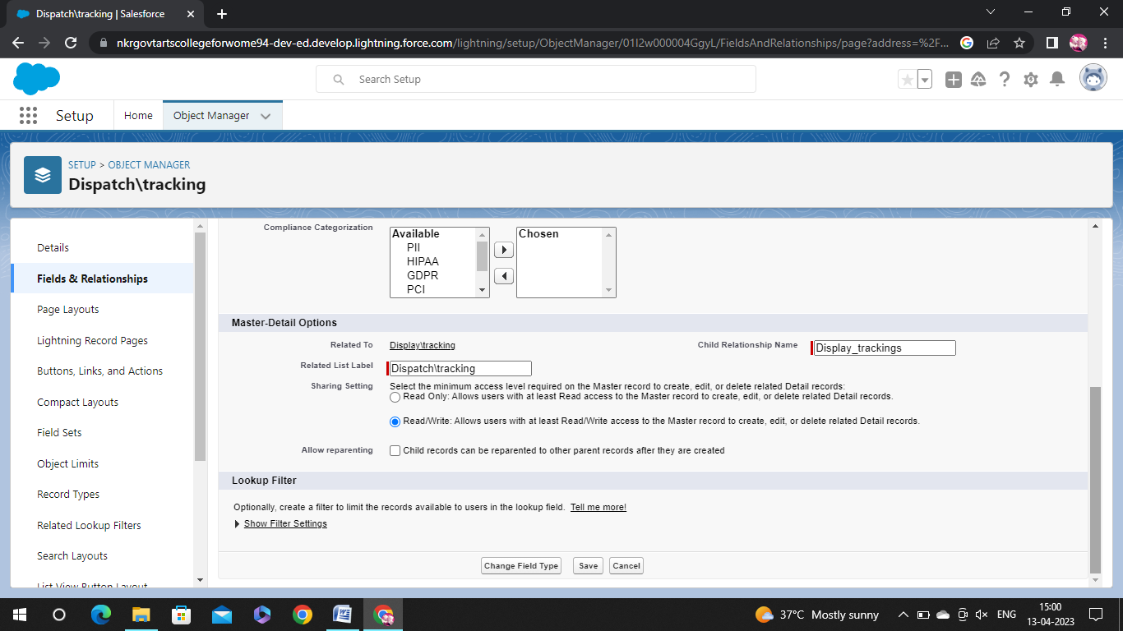

4. Application:

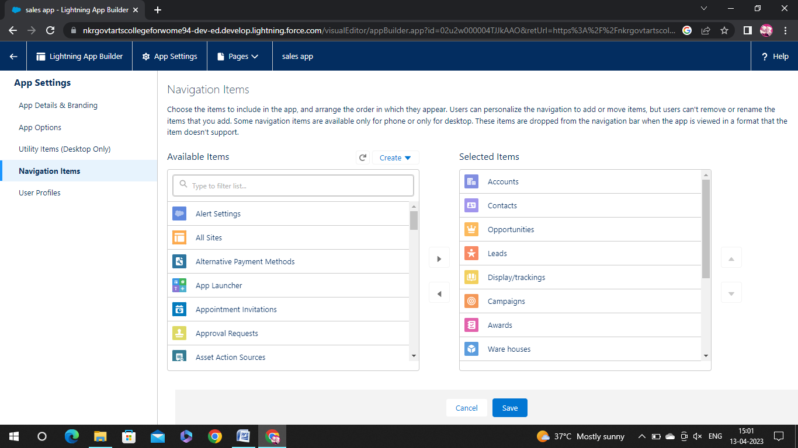

5. Layouts:

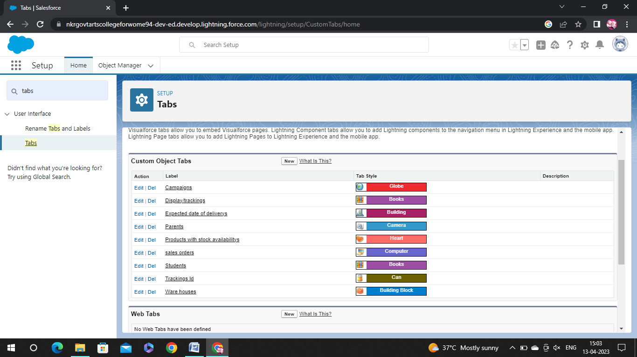

6. Users:

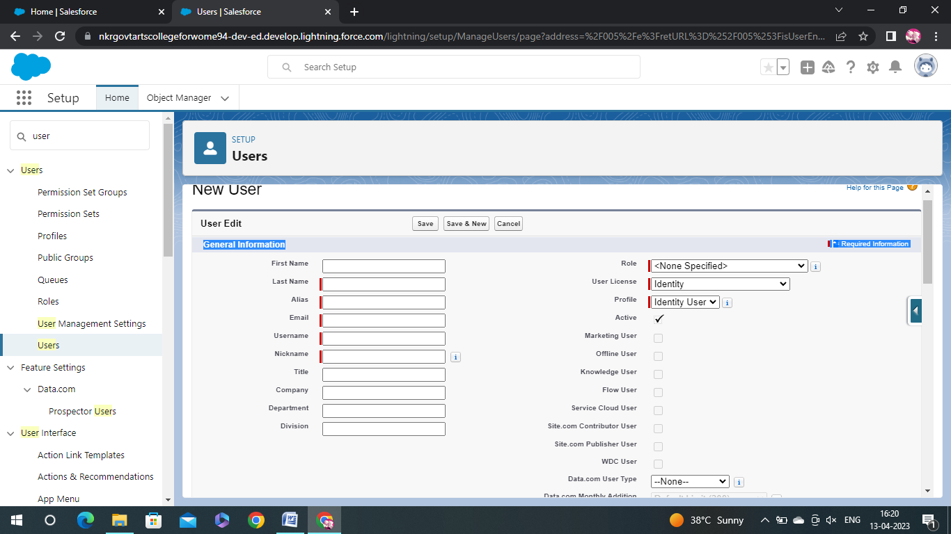

7. Validation rules:

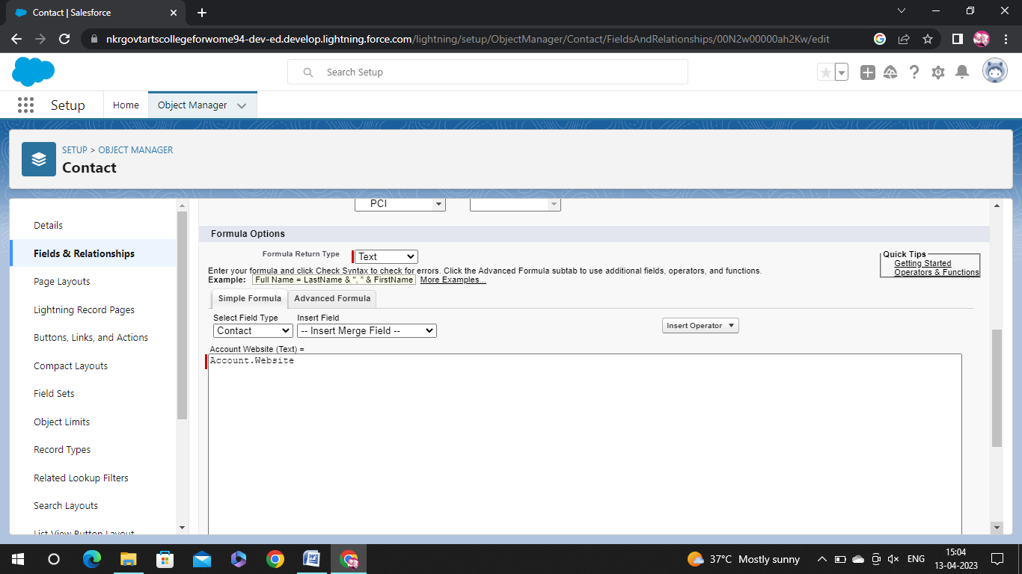 7. Reports:

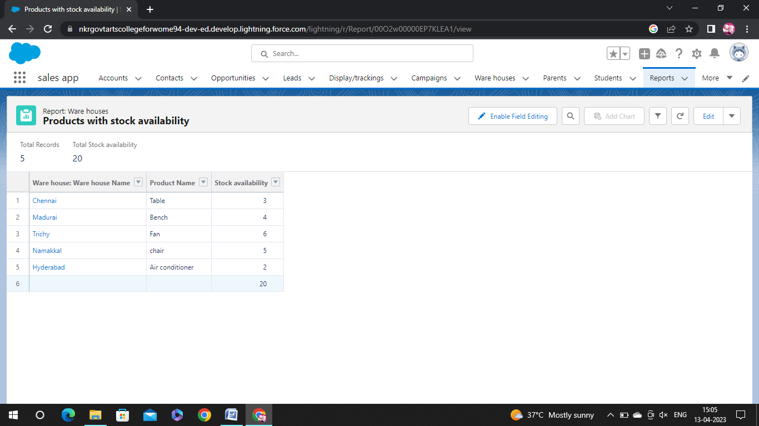

8. Dashboards:

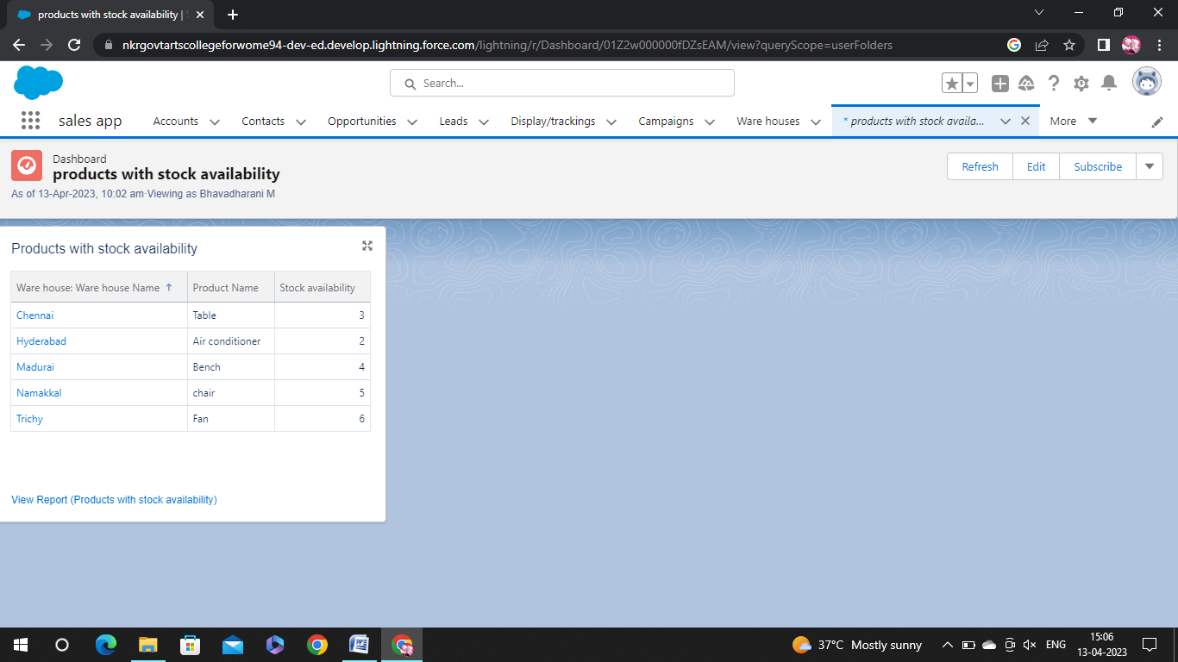

# 4 Trailhead Profile Public URL

# Team Lead https: //trailblazer.me/id/ubhavadharanim

# Team Member 1- <https://trailblazer.me/id/uanusiyak>

# Team Member2-https://trailblazer.me/id/djagathis

# Team Member3-https://trailblazer.me/id/udivyac

**6. ADVANTAGES & DISADVANTAGE**

* The retails Sector consists of retailing and retailers. Retailing.
* Customer’s Empathy.
* Greater deliver Options.
* Fewer Complexities.

**7. APPLICATIONS:**

Retail Management optimizes internal processes such as inventory management, offline and online storefronts, warehouse opration, payment and accounting and human resources.

**8. CONCLUSION:**

Salesforce for retail is a set of solutions built on the salesforce platform designed to help retail companies manage their operations and customer relationships these solutions include tools for managing inventory, sales, customerdata Marketing and more.

# 9. FUTURE SCOP:

# Supervisory, clinet comunction. Merchandise services are all options for candidates with a retail management background. More than 2 million jobs are available in retails management around the world.